|  |
| --- |
| **Course: CSE 462 - Network Analysis and Design**  **LAB 2 – Switch Networks** |

|  |  |
| --- | --- |
| **Student Name** | *Write your name here* |
| **Student ID** | *Write your ID here* |
| **Final Score** |  |

**Lab Exercise Submission**

Students are responsible for submitting the final report by the stated deadline for full marks. Late submissions will NOT be accepted.

**Objective:** This lab is to guide students how to build switch networks.

**NOTE:** *Students should read the guideline carefully before conducting Lab experiments.*

**🙡 - Good luck - 🙣**

# TASK 1 – HOW TO RESET SWITCH

Switch>**enable**

Switch#**delete flash:vlan.dat**

Delete filename [vlan.dat]?[**Enter**]

Delete flash:vlan.dat? [confirm] [**Enter**]

If there was no VLAN file, this message is displayed.

%Error deleting flash:vlan.dat (No such file or directory)

Switch#**erase startup-config**

Erasing the nvram filesystem will remove all files! Continue? [confirm] **Enter**

Erase of nvram: complete

**Use the reload command to reboot the switch:**

Switch#**reload**

System configuration has been modified. Save? [yes/no]: **n**

Proceed with reload? [confirm] [**Enter**]

Reload requested by console.

Would you like to enter the initial configuration dialog? [yes/no]: **n**

Press RETURN to get started! [**Enter**]

# TASK 2 – BASIC SWITCH NETWORK

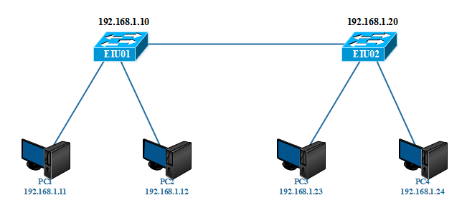

*Figure 2.1. Basic switch network diagram*

**Make device connections according to the above model.**

***Note****: Delete old configuration information existing in the devices before proceeding*

**Step 1: Make connections according to the diagram and configure basic parameters for the Switch (See lab 1)**

- Set **hostname, banner**

- Set enable pass as **“eiu@123”**

- Configure and set password for **telnet** sessions, password is **“cisco”**

**Step 2: Configure IP for switches and PCs**

To configure the IP for the Switch, **you must go to interface vlan1**, and the IP on the switch only is for the management purpose.

EIU01(config)#**interface vlan 1**

EIU01(config-if)#**ip address 192.168.1.10 255.255.255.0**

EIU01(config-if)#**no shutdown**

EIU01(config-if)#**exit**

EIU01(config)#**ip default-gateway 192.168.1.1**

EIU01#**copy running-config startup-config**

***NOTE: Do the same on the remaining devices***

**Step 3: Check configuration information:**

EIU01#**show running-config**

EIU01#**show vlan**

EIU01#**show mac-address-table**

Execute the command to **delete old information** in the MAC address table:

EIU01#**clear mac-address-table**

Then **review the information** in the MAC address table:

EIU01#**show mac-address-table**

**Step 4: Check the connection between PCs and between PC and Switch**

1. Use the **Ping** command from PC1 to the switch, and other PCs in the model.
2. Observe the **Ping** process. If it **fails**, you must **check configuration again.**
3. From PC1, **telnet** to the Switches in the model.

# TASK 3 – EXTENTED SWITCH NETWORK

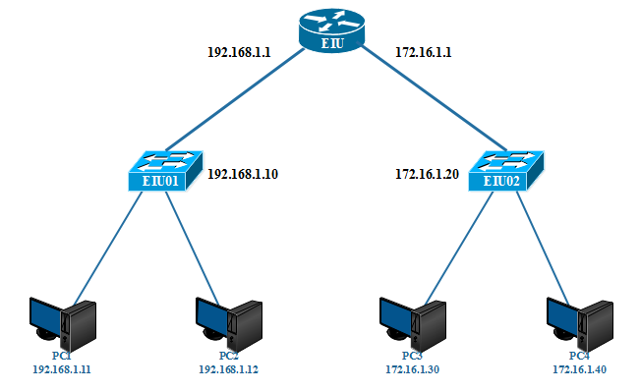

*Figure 2.2. Expanded switch network diagram.*

**Step 1: Make connections according to the diagram and configure basic parameters for the Switch (See lab 1)**

- Set **hostname, banner**

- Set enable pass as **“eiu@123”**

- Configure and set password for **telnet** sessions, password is **“cisco”**

**Step 2: Configure IP for switches, routers and PCs**

In the above model, can it **work without a Router device**? What is the role of the Router in the above model?

***Answer:***

**Step 3: Check configuration information:**

#**show running-config**

#**show vlan**

#**show ip route**

**#show ip interface brief**

**Step 4: Check the connection between PCs, Switch and Router**

1. Use the **Ping** command from PC1 to the switch, and other PCs in the model.
2. Observe the **Ping** process. If it **fails**, you must **check again.**
3. From PC, **telnet** to the Switches in the model.

# TASK 4 – VLAN and TRUNKING

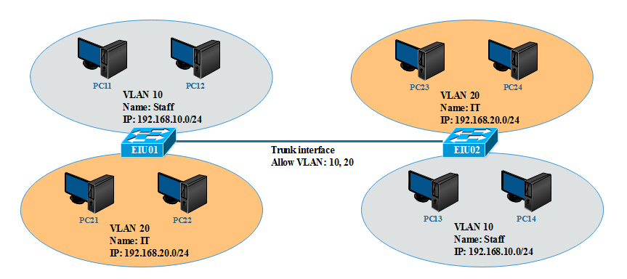

*Figure 2.3. Switch network diagram with VLAN and trunking*

* + - **VLAN 10: port 4, 5, 6**
    - **VLAN 20: port 7, 8, 9**
    - **Trunk: port 15**

**Step 1: Make connections according to the diagram and configure basic parameters for the Switch (See lab 1)**

* + - Set **hostname, banner**
    - Set enable pass as **“eiu@123”**
    - Configure and set password for **telnet** sessions, password is **“cisco”**

**Step 2: Assign IP addresses to PCs**

**Example PC11:**

- *IP address*: 192.168.10.11

- *Subnet mask*: 255.255.255.0

***Do the appropriate configuration for other PCs***

**Step 3: Create VLANs on SWITCHs**

**Switch EIU01**

EIU01#**show vlan**

EIU01(config)#**vlan 10**

EIU01(config-vlan)#**name Staff**

EIU01(config)#**vlan 20**

EIU01(config-vlan)# **name IT**

EIU01#**show vlan**

***Do the same for switch EIU02***

**Step 4: Assign ports to VLANs**

**Switch EIU01:**

Assign ports Fa0/4, Fa0/5, Fa0/6 to VLAN 10

EIU01(config)#**interface fastethernet 0/4**

EIU01(config-if)#**switchport mode access**

EIU01(config-if)#**switchport access vlan 10**

EIU01(config-if)#**interface fastethernet 0/5**

EIU01(config-if)#**switchport mode access**

EIU01(config-if)#**switchport access vlan 10**

EIU01(config-if)#**interface fastethernet 0/6**

EIU01(config-if)#**switchport mode access**

EIU01(config-if)#**switchport access vlan 10**

***Do the same for VLAN 20 and on Switch EIU02***

**Check the configuration information again:**

EIU01#**show vlan**

EIU01#**show running-config**

**Step 5: Check the connection between PCs**

1. Can PC11 ping PC12? Why? **Answer:**

2. Can PC11 ping PC13? Why? **Answer:**

**Step 6: Create Trunk port with Encapsulation dot1q**

**Switch EIU01:**

EIU01(config)#**interface fastethernet 0/1**5

EIU01(config-if)#**switchport mode trunk**

EIU01(config-if)#**switchport trunk encapsulation dot1q**

EIU01(config-if)# **switchport trunk allowed vlan 10,12,13**

***Do the same with switch EIU02***

**Step 7: Check information on the Trunk interface with the following commands:**

**#show interface fastethernet 0/15 switchport**

**#show interface fastethernet 0/15**

**#show running-config**

**#show vlan**

**Step 8: Check the connection between PCs**

1. Can PC11 ping PC13? Why?

2. Can PC11 ping PC24? Why?

3. If **the PING was failed, suggest a solution to PING successfully**.

***Answer:***